AnkiDriod-7836

Apk

AnkiDroid-2.15alpha10-x86.apk

<https://github.com/ankidroid/Anki-Android/releases?q=2.14alpha9&expanded=true>

Bug report description

<https://github.com/ankidroid/Anki-Android/issues/7836>

**Reproduction Steps**

* Settings - Reviewing - Disable "black strokes"
* Settings - Appearance - Select Plain Theme
* Enable whiteboard, draw and save

**Expected Result**

Blue on white background

**Actual Result**

Blue on black background

Debug info

2.15alpha10

Screen shots sequence

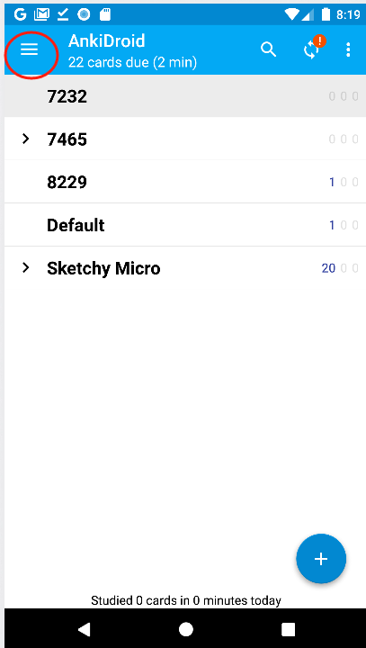

Uncheck ‘Black strokes’

The .png it saved:

